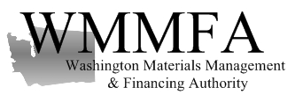

Regular Meeting of the Board of Directors
Thursday, July 18, 2019 - 9:30 am PST

Offices of Van Ness Feldman PC
719 Second Avenue, Suite 1150
Seattle, Washington 98104

Conference call number: 1-563-999-2090 Access code: 755212#

AGENDA

- Call to order – Brandon Seegmiller

- Approve minutes of the: May 16, 2019 regular meeting of the Board (Board vote) – Brandon Seegmiller

- Report on 2019 YTD June operational and financial results – John Friedrick
- Pounds by CEP totals
- Financial reports
- Unpaid past due manufacturer’s invoices to date

- 2019 Q4 budget discussion and revised annual projections – proposal (Board vote) - John Friedrick

- Processing Capacity and Standards - WMMFA - discussion and update – John Friedrick

6. Local Governments E-Cycle Satisfaction Survey Results / Response – John Friedrick

7. Court ordered restitution to WMMFA from Western District Court – Total reclaim case – Board and
management discussion with possible board vote

8. Matters to discuss at future meetings
  - Annual “in person” meeting dates and location – update and discussion

Adjourn meeting

